OLADIMEJI ALADEROKUN

219047012

SSG831 COMPUTER PROGRAMMING FOR ENGINEERS



1.

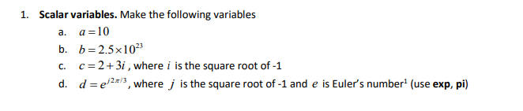

%1.a

a = 10

a =  
  
 10

%1.b

b = 2.5 \* 10^23

b =  
  
 2.5000e+23

%1.c

2 + 3i

ans =  
  
 2.0000 + 3.0000i

%1.d

exp(j\*2\*pi/3)

ans =  
  
 -0.5000 + 0.8660i

2.

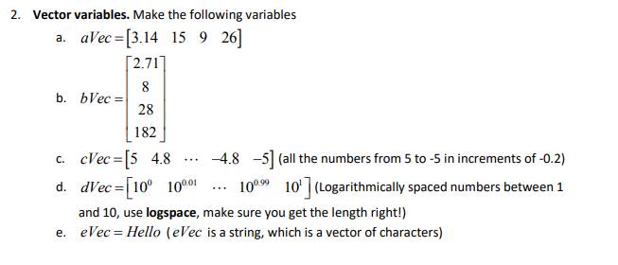

%2.a

aVec=[3.14 15 9 26]

aVec =  
  
 3.1400 15.0000 9.0000 26.0000

%2.b

bVec = [2.71; 8; 28; 182]

bVec =  
  
 2.7100  
 8.0000  
 28.0000  
 182.0000

%2.c

cVec=[5:-0.2:-5]

cVec =  
  
 Columns 1 through 14  
  
 5.0000 4.8000 4.6000 4.4000 4.2000 4.0000 3.8000 3.6000 3.4000 3.2000 3.0000 2.8000 2.6000 2.4000  
  
 Columns 15 through 28  
  
 2.2000 2.0000 1.8000 1.6000 1.4000 1.2000 1.0000 0.8000 0.6000 0.4000 0.2000 0 -0.2000 -0.4000  
  
 Columns 29 through 42  
  
 -0.6000 -0.8000 -1.0000 -1.2000 -1.4000 -1.6000 -1.8000 -2.0000 -2.2000 -2.4000 -2.6000 -2.8000 -3.0000 -3.2000  
  
 Columns 43 through 51  
  
 -3.4000 -3.6000 -3.8000 -4.0000 -4.2000 -4.4000 -4.6000 -4.8000 -5.0000

%2.d

%2.d

dVec=logspace(0,1,101)

dVec =  
  
 Columns 1 through 14  
  
 1.0000 1.0233 1.0471 1.0715 1.0965 1.1220 1.1482 1.1749 1.2023 1.2303 1.2589 1.2882 1.3183 1.3490  
  
 Columns 15 through 28  
  
 1.3804 1.4125 1.4454 1.4791 1.5136 1.5488 1.5849 1.6218 1.6596 1.6982 1.7378 1.7783 1.8197 1.8621  
  
 Columns 29 through 42  
  
 1.9055 1.9498 1.9953 2.0417 2.0893 2.1380 2.1878 2.2387 2.2909 2.3442 2.3988 2.4547 2.5119 2.5704  
  
 Columns 43 through 56  
  
 2.6303 2.6915 2.7542 2.8184 2.8840 2.9512 3.0200 3.0903 3.1623 3.2359 3.3113 3.3884 3.4674 3.5481  
  
 Columns 57 through 70  
  
 3.6308 3.7154 3.8019 3.8905 3.9811 4.0738 4.1687 4.2658 4.3652 4.4668 4.5709 4.6774 4.7863 4.8978  
  
 Columns 71 through 84  
  
 5.0119 5.1286 5.2481 5.3703 5.4954 5.6234 5.7544 5.8884 6.0256 6.1660 6.3096 6.4565 6.6069 6.7608  
  
 Columns 85 through 98  
  
 6.9183 7.0795 7.2444 7.4131 7.5858 7.7625 7.9433 8.1283 8.3176 8.5114 8.7096 8.9125 9.1201 9.3325  
  
 Columns 99 through 101  
  
 9.5499 9.7724 10.0000

%2.e

eVec="Hello"

eVec =   
  
 "Hello"

3.

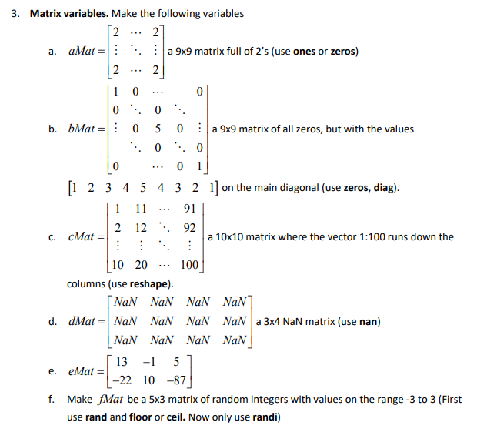

%3.a

aMat = 2\*ones(9)

aMat =  
  
 2 2 2 2 2 2 2 2 2  
 2 2 2 2 2 2 2 2 2  
 2 2 2 2 2 2 2 2 2  
 2 2 2 2 2 2 2 2 2  
 2 2 2 2 2 2 2 2 2  
 2 2 2 2 2 2 2 2 2  
 2 2 2 2 2 2 2 2 2  
 2 2 2 2 2 2 2 2 2  
 2 2 2 2 2 2 2 2 2

%3.b

bMat=diag([1:5 4:-1:1])

bMat =  
  
 1 0 0 0 0 0 0 0 0  
 0 2 0 0 0 0 0 0 0  
 0 0 3 0 0 0 0 0 0  
 0 0 0 4 0 0 0 0 0  
 0 0 0 0 5 0 0 0 0  
 0 0 0 0 0 4 0 0 0  
 0 0 0 0 0 0 3 0 0  
 0 0 0 0 0 0 0 2 0  
 0 0 0 0 0 0 0 0 1

%3.c

cMat=reshape(1:100,10,10)

cMat =  
  
 1 11 21 31 41 51 61 71 81 91  
 2 12 22 32 42 52 62 72 82 92  
 3 13 23 33 43 53 63 73 83 93  
 4 14 24 34 44 54 64 74 84 94  
 5 15 25 35 45 55 65 75 85 95  
 6 16 26 36 46 56 66 76 86 96  
 7 17 27 37 47 57 67 77 87 97  
 8 18 28 38 48 58 68 78 88 98  
 9 19 29 39 49 59 69 79 89 99  
 10 20 30 40 50 60 70 80 90 100

%3.d

dMat = NaN(3,4)

dMat =  
  
 NaN NaN NaN NaN  
 NaN NaN NaN NaN  
 NaN NaN NaN NaN

%3.e

eMat=[13 -1 5 ; -22 10 -87]

eMat =  
  
 13 -1 5  
 -22 10 -87

%3.f

fMat= fix(8\*rand(3,4)-4)

fMat =  
  
 2 3 2 -3  
 0 -1 0 -3  
 0 2 0 0

4.

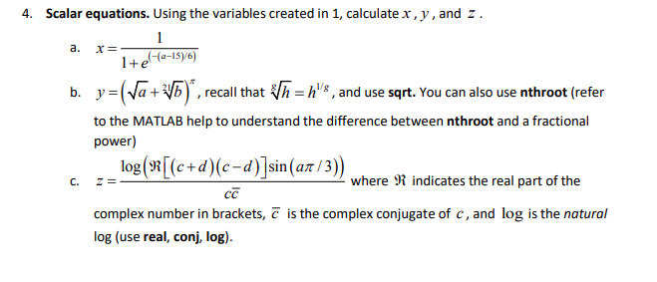

%4.a

x=1/(1+exp(-(a-15)/6))

x =  
  
 0.3029

%4.b

y=(sqrt(a) + b^(1/21))^pi

y =  
  
 6.2696e+03

%4.c

z=log(real((c+d)\*(c-d))\*sin(a\*pi/3))/(c\*conj(c))

z =  
  
 0.1046

5.

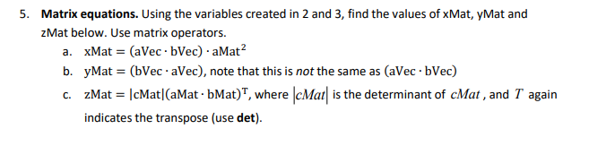

%5.a

xMat=(aVec\*bVec)\*aMat^2

xMat =  
  
 1.0e+05 \*  
  
 1.8405 1.8405 1.8405 1.8405 1.8405 1.8405 1.8405 1.8405 1.8405  
 1.8405 1.8405 1.8405 1.8405 1.8405 1.8405 1.8405 1.8405 1.8405  
 1.8405 1.8405 1.8405 1.8405 1.8405 1.8405 1.8405 1.8405 1.8405  
 1.8405 1.8405 1.8405 1.8405 1.8405 1.8405 1.8405 1.8405 1.8405  
 1.8405 1.8405 1.8405 1.8405 1.8405 1.8405 1.8405 1.8405 1.8405  
 1.8405 1.8405 1.8405 1.8405 1.8405 1.8405 1.8405 1.8405 1.8405  
 1.8405 1.8405 1.8405 1.8405 1.8405 1.8405 1.8405 1.8405 1.8405  
 1.8405 1.8405 1.8405 1.8405 1.8405 1.8405 1.8405 1.8405 1.8405  
 1.8405 1.8405 1.8405 1.8405 1.8405 1.8405 1.8405 1.8405 1.8405

%5.b

yMat=bVec\*aVec

yMat =  
  
 1.0e+03 \*  
  
 0.0085 0.0406 0.0244 0.0705  
 0.0251 0.1200 0.0720 0.2080  
 0.0879 0.4200 0.2520 0.7280  
 0.5715 2.7300 1.6380 4.7320

%5.c

zMat=det(cMat)\*(aMat\*bMat)'

zMat =  
  
 0 0 0 0 0 0 0 0 0  
 0 0 0 0 0 0 0 0 0  
 0 0 0 0 0 0 0 0 0  
 0 0 0 0 0 0 0 0 0  
 0 0 0 0 0 0 0 0 0  
 0 0 0 0 0 0 0 0 0  
 0 0 0 0 0 0 0 0 0  
 0 0 0 0 0 0 0 0 0  
 0 0 0 0 0 0 0 0 0

6.

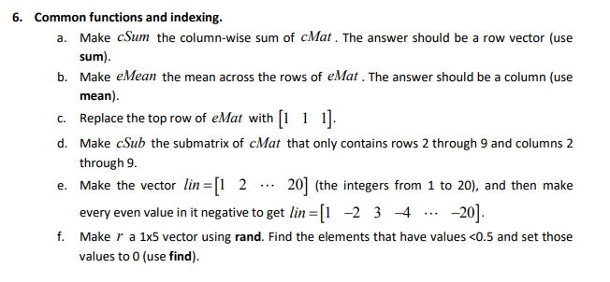

%6.a

cSum=sum(cMat, 1)

cSum =  
  
 55 155 255 355 455 555 655 755 855 955

%6.b

eMean=mean(eMat,2)

eMean =  
  
 5.6667  
 -33.0000

%6.c

eMat(1,:) =[1 1 1]

eMat =  
  
 1 1 1  
 -22 10 -87

%6.d

cSub=cMat(2:9,2:9)

cSub =  
  
 12 22 32 42 52 62 72 82  
 13 23 33 43 53 63 73 83  
 14 24 34 44 54 64 74 84  
 15 25 35 45 55 65 75 85  
 16 26 36 46 56 66 76 86  
 17 27 37 47 57 67 77 87  
 18 28 38 48 58 68 78 88  
 19 29 39 49 59 69 79 89

%6.e

lin = 1:20

lin =  
  
 1 2 3 4 5 6 7 8 9 10 11 12 13 14 15 16 17 18 19 20

lin(2:2:end)=-lin(2:2:end)

lin =  
  
 1 -2 3 -4 5 -6 7 -8 9 -10 11 -12 13 -14 15 -16 17 -18 19 -20

%6.f

r=rand(1,5)

inds=find(r<0.5)

r(inds)=0

r =  
  
 0.7792 0.9340 0.1299 0.5688 0.4694  
  
  
inds =  
  
 3 5  
  
  
r =  
  
 0.7792 0.9340 0 0.5688 0

%7.

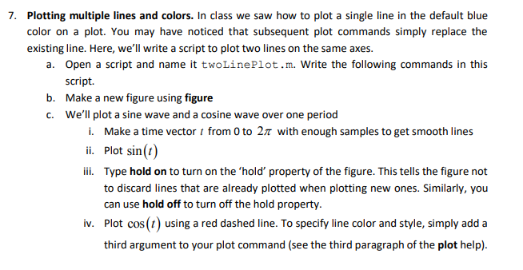

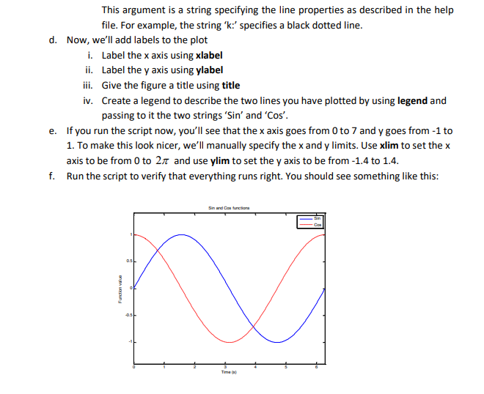

figure

t=0:.01:2\*pi

t =  
  
 Columns 1 through 14  
  
 0 0.0100 0.0200 0.0300 0.0400 0.0500 0.0600 0.0700 0.0800 0.0900 0.1000 0.1100 0.1200 0.1300  
  
 Columns 15 through 28  
  
 0.1400 0.1500 0.1600 0.1700 0.1800 0.1900 0.2000 0.2100 0.2200 0.2300 0.2400 0.2500 0.2600 0.2700  
  
 Columns 29 through 42  
  
 0.2800 0.2900 0.3000 0.3100 0.3200 0.3300 0.3400 0.3500 0.3600 0.3700 0.3800 0.3900 0.4000 0.4100  
  
 Columns 43 through 56  
  
 0.4200 0.4300 0.4400 0.4500 0.4600 0.4700 0.4800 0.4900 0.5000 0.5100 0.5200 0.5300 0.5400 0.5500  
  
 Columns 57 through 70  
  
 0.5600 0.5700 0.5800 0.5900 0.6000 0.6100 0.6200 0.6300 0.6400 0.6500 0.6600 0.6700 0.6800 0.6900  
  
 Columns 71 through 84  
  
 0.7000 0.7100 0.7200 0.7300 0.7400 0.7500 0.7600 0.7700 0.7800 0.7900 0.8000 0.8100 0.8200 0.8300  
  
 Columns 85 through 98  
  
 0.8400 0.8500 0.8600 0.8700 0.8800 0.8900 0.9000 0.9100 0.9200 0.9300 0.9400 0.9500 0.9600 0.9700  
  
 Columns 99 through 112  
  
 0.9800 0.9900 1.0000 1.0100 1.0200 1.0300 1.0400 1.0500 1.0600 1.0700 1.0800 1.0900 1.1000 1.1100  
  
 Columns 113 through 126  
  
 1.1200 1.1300 1.1400 1.1500 1.1600 1.1700 1.1800 1.1900 1.2000 1.2100 1.2200 1.2300 1.2400 1.2500  
  
 Columns 127 through 140  
  
 1.2600 1.2700 1.2800 1.2900 1.3000 1.3100 1.3200 1.3300 1.3400 1.3500 1.3600 1.3700 1.3800 1.3900  
  
 Columns 141 through 154  
  
 1.4000 1.4100 1.4200 1.4300 1.4400 1.4500 1.4600 1.4700 1.4800 1.4900 1.5000 1.5100 1.5200 1.5300  
  
 Columns 155 through 168  
  
 1.5400 1.5500 1.5600 1.5700 1.5800 1.5900 1.6000 1.6100 1.6200 1.6300 1.6400 1.6500 1.6600 1.6700  
  
 Columns 169 through 182  
  
 1.6800 1.6900 1.7000 1.7100 1.7200 1.7300 1.7400 1.7500 1.7600 1.7700 1.7800 1.7900 1.8000 1.8100  
  
 Columns 183 through 196  
  
 1.8200 1.8300 1.8400 1.8500 1.8600 1.8700 1.8800 1.8900 1.9000 1.9100 1.9200 1.9300 1.9400 1.9500  
  
 Columns 197 through 210  
  
 1.9600 1.9700 1.9800 1.9900 2.0000 2.0100 2.0200 2.0300 2.0400 2.0500 2.0600 2.0700 2.0800 2.0900  
  
 Columns 211 through 224  
  
 2.1000 2.1100 2.1200 2.1300 2.1400 2.1500 2.1600 2.1700 2.1800 2.1900 2.2000 2.2100 2.2200 2.2300  
  
 Columns 225 through 238  
  
 2.2400 2.2500 2.2600 2.2700 2.2800 2.2900 2.3000 2.3100 2.3200 2.3300 2.3400 2.3500 2.3600 2.3700  
  
 Columns 239 through 252  
  
 2.3800 2.3900 2.4000 2.4100 2.4200 2.4300 2.4400 2.4500 2.4600 2.4700 2.4800 2.4900 2.5000 2.5100  
  
 Columns 253 through 266  
  
 2.5200 2.5300 2.5400 2.5500 2.5600 2.5700 2.5800 2.5900 2.6000 2.6100 2.6200 2.6300 2.6400 2.6500  
  
 Columns 267 through 280  
  
 2.6600 2.6700 2.6800 2.6900 2.7000 2.7100 2.7200 2.7300 2.7400 2.7500 2.7600 2.7700 2.7800 2.7900  
  
 Columns 281 through 294  
  
 2.8000 2.8100 2.8200 2.8300 2.8400 2.8500 2.8600 2.8700 2.8800 2.8900 2.9000 2.9100 2.9200 2.9300  
  
 Columns 295 through 308  
  
 2.9400 2.9500 2.9600 2.9700 2.9800 2.9900 3.0000 3.0100 3.0200 3.0300 3.0400 3.0500 3.0600 3.0700  
  
 Columns 309 through 322  
  
 3.0800 3.0900 3.1000 3.1100 3.1200 3.1300 3.1400 3.1500 3.1600 3.1700 3.1800 3.1900 3.2000 3.2100  
  
 Columns 323 through 336  
  
 3.2200 3.2300 3.2400 3.2500 3.2600 3.2700 3.2800 3.2900 3.3000 3.3100 3.3200 3.3300 3.3400 3.3500  
  
 Columns 337 through 350  
  
 3.3600 3.3700 3.3800 3.3900 3.4000 3.4100 3.4200 3.4300 3.4400 3.4500 3.4600 3.4700 3.4800 3.4900  
  
 Columns 351 through 364  
  
 3.5000 3.5100 3.5200 3.5300 3.5400 3.5500 3.5600 3.5700 3.5800 3.5900 3.6000 3.6100 3.6200 3.6300  
  
 Columns 365 through 378  
  
 3.6400 3.6500 3.6600 3.6700 3.6800 3.6900 3.7000 3.7100 3.7200 3.7300 3.7400 3.7500 3.7600 3.7700  
  
 Columns 379 through 392  
  
 3.7800 3.7900 3.8000 3.8100 3.8200 3.8300 3.8400 3.8500 3.8600 3.8700 3.8800 3.8900 3.9000 3.9100  
  
 Columns 393 through 406  
  
 3.9200 3.9300 3.9400 3.9500 3.9600 3.9700 3.9800 3.9900 4.0000 4.0100 4.0200 4.0300 4.0400 4.0500  
  
 Columns 407 through 420  
  
 4.0600 4.0700 4.0800 4.0900 4.1000 4.1100 4.1200 4.1300 4.1400 4.1500 4.1600 4.1700 4.1800 4.1900  
  
 Columns 421 through 434  
  
 4.2000 4.2100 4.2200 4.2300 4.2400 4.2500 4.2600 4.2700 4.2800 4.2900 4.3000 4.3100 4.3200 4.3300  
  
 Columns 435 through 448  
  
 4.3400 4.3500 4.3600 4.3700 4.3800 4.3900 4.4000 4.4100 4.4200 4.4300 4.4400 4.4500 4.4600 4.4700  
  
 Columns 449 through 462  
  
 4.4800 4.4900 4.5000 4.5100 4.5200 4.5300 4.5400 4.5500 4.5600 4.5700 4.5800 4.5900 4.6000 4.6100  
  
 Columns 463 through 476  
  
 4.6200 4.6300 4.6400 4.6500 4.6600 4.6700 4.6800 4.6900 4.7000 4.7100 4.7200 4.7300 4.7400 4.7500  
  
 Columns 477 through 490  
  
 4.7600 4.7700 4.7800 4.7900 4.8000 4.8100 4.8200 4.8300 4.8400 4.8500 4.8600 4.8700 4.8800 4.8900  
  
 Columns 491 through 504  
  
 4.9000 4.9100 4.9200 4.9300 4.9400 4.9500 4.9600 4.9700 4.9800 4.9900 5.0000 5.0100 5.0200 5.0300  
  
 Columns 505 through 518  
  
 5.0400 5.0500 5.0600 5.0700 5.0800 5.0900 5.1000 5.1100 5.1200 5.1300 5.1400 5.1500 5.1600 5.1700  
  
 Columns 519 through 532  
  
 5.1800 5.1900 5.2000 5.2100 5.2200 5.2300 5.2400 5.2500 5.2600 5.2700 5.2800 5.2900 5.3000 5.3100  
  
 Columns 533 through 546  
  
 5.3200 5.3300 5.3400 5.3500 5.3600 5.3700 5.3800 5.3900 5.4000 5.4100 5.4200 5.4300 5.4400 5.4500  
  
 Columns 547 through 560  
  
 5.4600 5.4700 5.4800 5.4900 5.5000 5.5100 5.5200 5.5300 5.5400 5.5500 5.5600 5.5700 5.5800 5.5900  
  
 Columns 561 through 574  
  
 5.6000 5.6100 5.6200 5.6300 5.6400 5.6500 5.6600 5.6700 5.6800 5.6900 5.7000 5.7100 5.7200 5.7300  
  
 Columns 575 through 588  
  
 5.7400 5.7500 5.7600 5.7700 5.7800 5.7900 5.8000 5.8100 5.8200 5.8300 5.8400 5.8500 5.8600 5.8700  
  
 Columns 589 through 602  
  
 5.8800 5.8900 5.9000 5.9100 5.9200 5.9300 5.9400 5.9500 5.9600 5.9700 5.9800 5.9900 6.0000 6.0100  
  
 Columns 603 through 616  
  
 6.0200 6.0300 6.0400 6.0500 6.0600 6.0700 6.0800 6.0900 6.1000 6.1100 6.1200 6.1300 6.1400 6.1500  
  
 Columns 617 through 629  
  
 6.1600 6.1700 6.1800 6.1900 6.2000 6.2100 6.2200 6.2300 6.2400 6.2500 6.2600 6.2700 6.2800

plot(t, sin(t))

hold on

plot(t, cos(t), 'r--')

%label

xlabel('Time(s)')

ylabel('Function value')

title('Sin and Cos functions')

legend('Sin', 'Cos')

xlim([0 2\*pi])

ylim([-1.4 1.4])

